16.73: a) The frequency is greater than 2800 MHz; the thunderclouds, moving toward the installation, encounter more wavefronts per time than would a stationary cloud, and so an observer in the frame of the storm would detect a higher frequency. Using the result of Problem 16.71, with 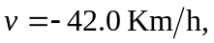

b) The waves are being sent at a higher frequency than 2800 MHz from an approaching source, and so are received at a higher frequency. Repeating the above calculation gives the result that the waves are detected at the installation with a frequency 109 Hz greater than the frequency with which the cloud received the waves, or 218 Hz higher than the frequency at which the waves were originally transmitted at the receiver. Note that in doing the second calculation, 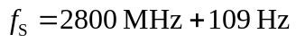is the same as 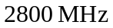to three figures.

